Name___________________________________

Quick Quiz

**Unit Rate 1**

Identify the unit rate:

1. 18 dollars for 8 books 2. $y=2x$

**$_________ per book unit rate =_________**

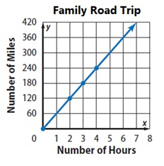

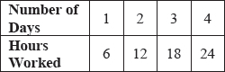3. 4.

**________**

**miles per hour**

**_________ hours per day**

____________________________________________________________________________

Corrections

**Unit Rate 1**

Identify the unit rate:

1. 18 dollars for 8 books 2.

**$_________ per book unit rate =_________**



3. 4.

**________**

**miles per hour**

**_________ hours per day**